**Mini Project Report - 04**

Master of Computer Application – General

Semester – III

**Sub: Web Technologies**

**Topic: Ganesha Greeting Card**   
By  
**Name:** SANDRA B  
**Reg no.:** 24110222500001

**Faculty Name:** VEERA RAGHAV K

**Faculty Signature: _______________**

**Department of Computer Application  
Alliance University  
Chandapura - Anekal Main Road, Anekal  
Bengaluru - 562 106**

**August 2025**

|  |  |  |
| --- | --- | --- |
| **Sno.** | **INDEX** | **Page No.** |
| 1. | Introduction | 2 |
| 2. | Objective | 2 |
| 3. | Tools and Technologies Used | 3 |
| 4. | Code Explanation | 3 |
| 5. | Learning Outcomes | 5 |
| 6. | Output | 5 |
| 7. | Conclusion | 6 |

**Ganesh Chaturthi Greeting Web Page**

**1. Introduction**

Ganesh Chaturthi, also known as **Vinayaka Chaturthi**, is one of the most important Hindu festivals celebrated in India to honor the birth of Lord Ganesha, the remover of obstacles and the god of wisdom, prosperity, and good fortune. People decorate their homes, install idols of Ganesha, perform prayers, and share greetings with loved ones during this festival.

With the increasing role of technology in everyday life, digital greetings have become a popular way to celebrate and spread festive cheer. This project, titled **“Ganesh Chaturthi Greeting”**, is designed as a digital greeting card created using **HTML5 and CSS3**. Instead of relying on traditional printed cards, this project demonstrates how **web technologies** can be used creatively to design festive greetings that can be shared easily over the internet.

The greeting card combines modern **web design elements** such as **gradients, flexbox layouts, image styling, and typography** with traditional cultural aspects like Sanskrit mantras and symbolic imagery of Lord Ganesha. It is not just a webpage but a representation of how technology can merge with culture to create meaningful digital experiences.

Through this project, the focus is on:

* Presenting the **cultural essence** of Ganesh Chaturthi in a visually attractive way.
* Learning how to structure and style web pages effectively.
* Exploring the creative side of coding by combining **design, colors, and symbolism**.

Thus, the project serves both as a **festive greeting platform** and as a **practical exercise in front-end web development**.

**2. Objectives**

The main objectives of this project are to combine **cultural representation** with **technical learning** by designing a digital greeting card for Ganesh Chaturthi using **HTML5 and CSS3**. The detailed objectives are as follows:

1. **Cultural Expression through Technology**
   * To digitally celebrate the festival of Ganesh Chaturthi by designing a greeting card that conveys traditional values, spirituality, and festive joy.
   * To integrate meaningful elements such as the **image of Lord Ganesha, Sanskrit shlokas (mantras), bells, and vibrant colors** to capture the cultural essence of the occasion.
2. **Practical Application of Web Development Skills**
   * To apply **HTML5** for the structure of the greeting card, including headings, paragraphs, images, and layouts.
   * To use **CSS3 styling techniques** such as gradients, flexbox, borders, shadows, and responsive design to create a visually appealing interface.
3. **Design & Aesthetics**
   * To design an **eye-catching greeting card** that balances colors, typography, and layout to make the card festive and engaging.
   * To experiment with **circular designs, background images, and radial gradients** for decorative purposes.
4. **Creativity & Innovation**
   * To encourage creativity in blending **traditional art with digital design**.
   * To show how **modern coding practices** can be used for artistic and cultural projects beyond technical applications.
5. **User Experience (UX)**
   * To create a greeting card that is simple, elegant, and easy to view on a web browser.
   * To provide a **personalized touch** by adding the designer’s name and festival wishes, giving the project a unique identity.
6. **Learning-Oriented Objective**
   * To strengthen understanding of **front-end development concepts**.
   * To demonstrate how **project-based learning** enhances both technical knowledge and cultural appreciation.

**3. Tools & Technologies Used**

* **HTML5**: For structuring the web page.
* **CSS3**: For styling, layout, gradients, and formatting.
* **Images**: Lord Ganesha image, circular designs, and border.
* **Text Styling**: Headings, mantras, and festive message formatting.

**4. Description of the Code**

The main objectives of this project are to combine cultural representation with technical learning by designing a digital greeting card for Ganesh Chaturthi using HTML5 and CSS3. The detailed objectives are as follows:

1. **Cultural Expression through Technology**
   * To digitally celebrate the festival of Ganesh Chaturthi by designing a greeting card that conveys traditional values, spirituality, and festive joy.
   * To integrate meaningful elements such as the image of Lord Ganesha, Sanskrit shlokas (mantras), bells, and vibrant colors to capture the cultural essence of the occasion.
2. **Practical Application of Web Development Skills**
   * To apply HTML5 for the structure of the greeting card, including headings, paragraphs, images, and layouts.
   * To use CSS3 styling techniques such as gradients, flexbox, borders, shadows, and responsive design to create a visually appealing interface.
3. **Design & Aesthetics**
   * To design an eye-catching greeting card that balances colors, typography, and layout to make the card festive and engaging.
   * To experiment with circular designs, background images, and radial gradients for decorative purposes.
4. **Creativity & Innovation**
   * To encourage creativity in blending traditional art with digital design.
   * To show how modern coding practices can be used for artistic and cultural projects beyond technical applications.
5. **User Experience (UX)**
   * To create a greeting card that is simple, elegant, and easy to view on a web browser.
   * To provide a personalized touch by adding the designer’s name and festival wishes, giving the project a unique identity.
6. **Learning-Oriented Objective**
   * To strengthen understanding of front-end development concepts.
   * To demonstrate how project-based learning enhances both technical knowledge and cultural appreciation.

**5. Learning Outcomes**

* Learned how to use **flexbox** for alignment and layout.
* Applied **radial & linear gradients** for festive design.
* Integrated **images with circular frames** using CSS.
* Improved skills in **responsive and creative web design**.
* Understood how **HTML structure and CSS styling** work together in themed projects.

1. **Output**

A digital greeting card with:

* + Decorative border.
  + Centered **Lord Ganesha image inside circular design**.
  + Festive message with mantra and blessings.
  + Bells as symbolic decoration.
  + Footer credit line.

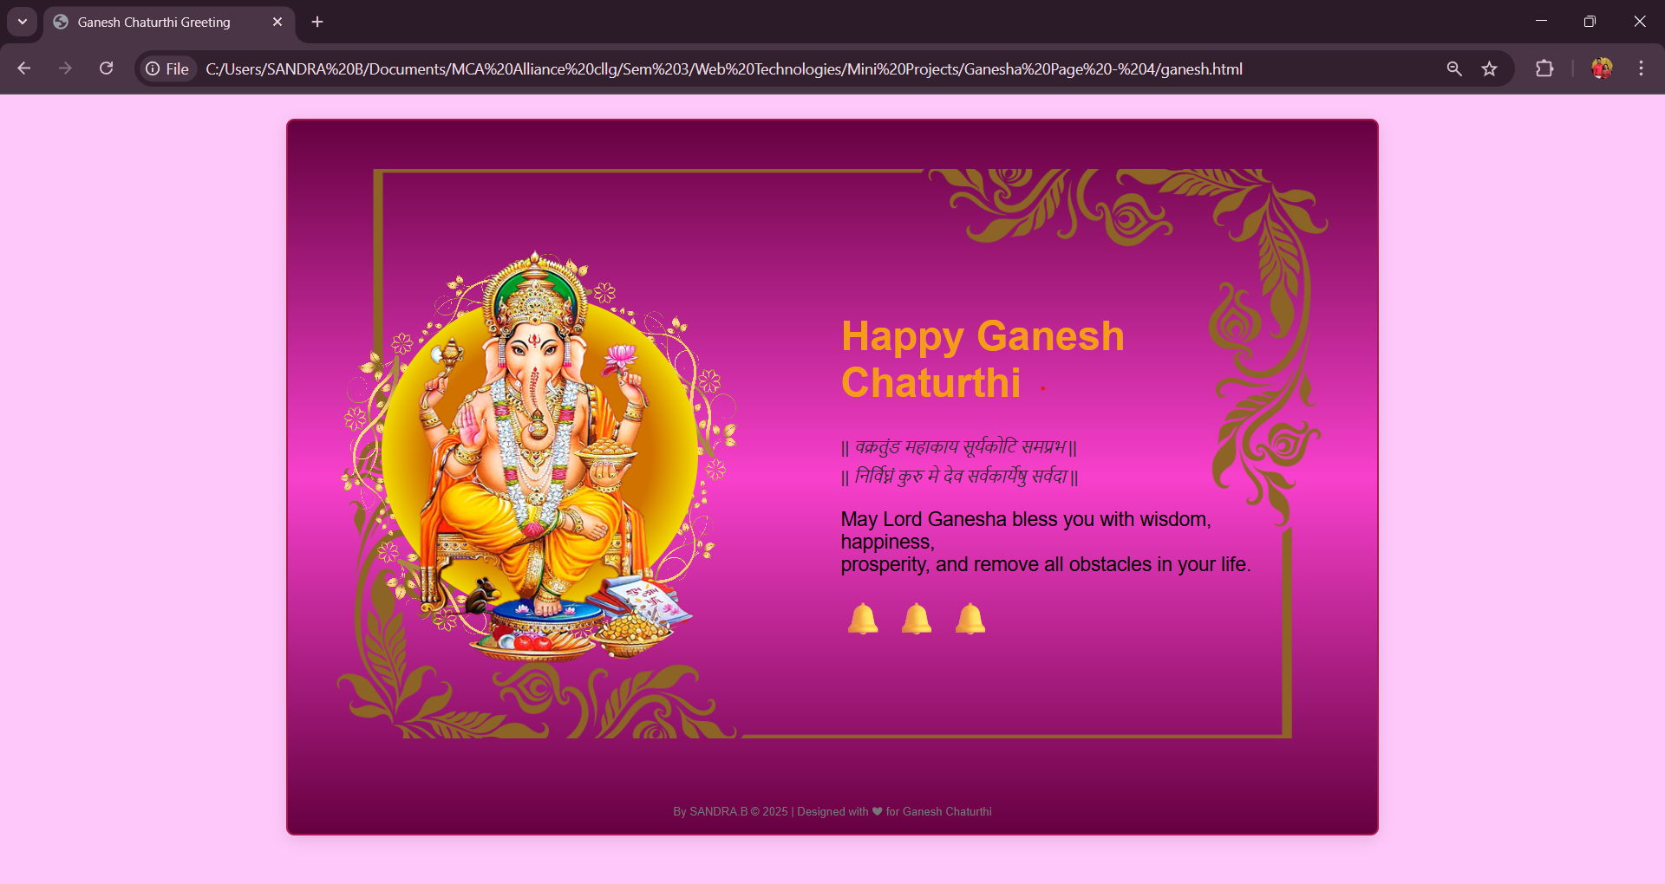

**7. Conclusion**

This project beautifully combines **cultural elements** with **modern web design**. It not only conveys the festive spirit of Ganesh Chaturthi but also showcases web development skills in **HTML5, CSS3, and layout design**.  
Such greeting projects can be extended for **other festivals and occasions**, making them reusable and versatile.